MANOVA

Nadia Ahmad

2023-03-17

# MANOVA Model on Travel Discrimination

Dataset explanation:  
**Dependent Variable:**  
- Q6_15 : checkin experience rate  
- Q6_18 : fly experience rate  
**Independent Variables:**  
**Categorical**  
- Q15 = Gender  
- Q17 = Race  
- Q18 = Religion  
**Continuos**  
- Q1_ = Travel frequency  
  
## Library

library(readr)  
library(readxl)  
library(tidyverse)  
library(corrplot)  
library(MASS)  
library(mvtnorm)  
library(MVN)  
library(psych)  
library(ggfortify)  
library(ggpubr)  
library(mvoutlier)  
library(heplots)  
library(biotools)  
library(emmeans)  
library(jmv)  
library(vegan)

## Read the dataset

travel <- read_excel("data_manova.xlsx")  
head(travel)

## # A tibble: 6 × 14  
## Respon…¹ UserL…² Text …³ Q1 Q1_ Q6_15 Q6_16 Q6_17 Q6_18 Q6_19 Q14 Q15   
## <chr> <chr> <chr> <chr> <chr> <chr> <chr> <chr> <chr> <chr> <chr> <chr>  
## 1 "Respon… "User … "Text … "How… "How… "How… "How… "How… "How… "How… "How… "To …  
## 2 "{\"Imp… "{\"Im… "{\"Im… "{\"… "{\"… "{\"… "{\"… "{\"… "{\"… "{\"… "{\"… "{\"…  
## 3 "R_33DB… "EN" "Yes" "<3 … "3" "54" "50" "71" "50" "51" "18-… "Fem…  
## 4 "R_32KM… "EN" "Yes" "<3 … "3" "52" "52" "51" "53" "52" "35-… "Mal…  
## 5 "R_1K2T… "EN" "Yes" "4-6… "5" <NA> <NA> <NA> <NA> <NA> "65+… "Mal…  
## 6 "R_2zBV… "EN" "Yes" "<3 … "3" "51" "53" "54" "52" "57" "25-… "Fem…  
## # … with 2 more variables: Q17 <chr>, Q18 <chr>, and abbreviated variable names  
## # ¹​ResponseId, ²​UserLanguage, ³​`Text / Graphic`

Dataset contains 231 rows and 14 columns which is still messy. Thus, we’ll conduct some data preprocessing steps.

## DATA PREPROCESSING

# First, drop two first rows. Next, filter only data that has 100 in progress  
travel <- travel %>%   
 slice(-c(1,2))  
  
# Select used columns  
travel_df <- travel[c(5,6,9,12,13,14)]

# CHECK MISSING VALUE----  
# Count the missing values by column wise  
print("Count of missing values by column wise")

## [1] "Count of missing values by column wise"

sapply(travel_df, function(x) sum(is.na(x)))

## Q1_ Q6_15 Q6_18 Q15 Q17 Q18   
## 30 72 75 74 72 78

# Missing value imputation  
# Since our data contains 46 missing value, let's impute with mode  
# Function to see mode  
calc_mode <- function(x){  
   
 # List the distinct / unique values  
 distinct_values <- unique(na.omit(x))  
   
 # Count the occurrence of each distinct value  
 distinct_tabulate <- tabulate(match(x, distinct_values))  
   
 # Return the value with the highest occurrence  
 distinct_values[which.max(distinct_tabulate)]  
}  
  
# Impute missing value----  
travel_df <- travel_df %>%   
 mutate(across(everything(), ~replace_na(.x, calc_mode(.x))))

# Rename column name  
travel_df_clean <- travel_df %>%   
 rename(travel_frequency = 1, checkin_exp = 2,  
 fly_exp = 3, gender = 4, race=5,  
 religion = 6)  
head(travel_df_clean)

## # A tibble: 6 × 6  
## travel_frequency checkin_exp fly_exp gender race religion  
## <chr> <chr> <chr> <chr> <chr> <chr>   
## 1 3 54 50 Female Asian Islam   
## 2 3 52 53 Male Black of African American Islam   
## 3 5 50 50 Male Asian Islam   
## 4 3 51 52 Female Asian Islam   
## 5 3 48 100 Male Asian Islam   
## 6 3 50 50 Male White Atheism…

# CONVERT DATA TYPE----  
# Convert all variables into integer  
# Convert column 2 to 6 to numeric  
travel_df_clean[,1:3] <- lapply(travel_df_clean[,1:3], as.numeric)  
travel_df_clean[,4:6] <- lapply(travel_df_clean[,4:6], as.factor)  
head(travel_df_clean)

## # A tibble: 6 × 6  
## travel_frequency checkin_exp fly_exp gender race religion  
## <dbl> <dbl> <dbl> <fct> <fct> <fct>   
## 1 3 54 50 Female Asian Islam   
## 2 3 52 53 Male Black of African American Islam   
## 3 5 50 50 Male Asian Islam   
## 4 3 51 52 Female Asian Islam   
## 5 3 48 100 Male Asian Islam   
## 6 3 50 50 Male White Atheism…

## 1. INTERACTION PLOT

#### Checkin Experience Rate

##### Gender vs Race

interaction.plot(  
 x.factor = travel_df_clean$race,  
 trace.factor = travel_df_clean$gender,  
 response = travel_df_clean$checkin_exp,  
 type="b", col=c(1:4),  
 ylab = "Checkin Experience Rate",  
 xlab = "Races",  
 trace.label = "Gender",  
 main="Interaction Plot",  
 leg.bty="o", leg.bg="beige", lwd=2,  
)

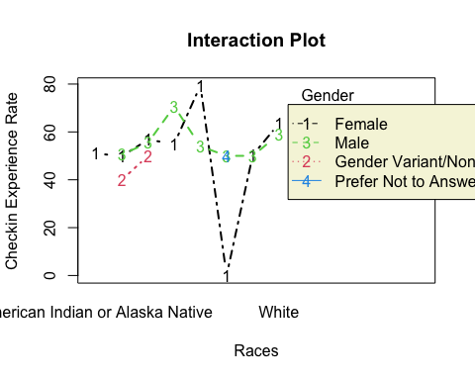

##### Gender vs Religion

interaction.plot(  
 x.factor = travel_df_clean$religion,  
 trace.factor = travel_df_clean$gender,  
 response = travel_df_clean$checkin_exp,  
 type="b", col=c(1:4),  
 ylab = "Checkin Experience Rate",  
 xlab = "Religion",  
 trace.label = "Gender",  
 main="Interaction Plot",  
 leg.bty="o", leg.bg="beige", lwd=2,  
)

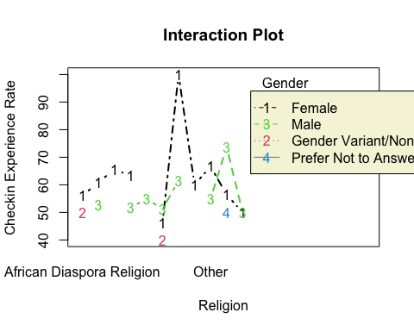

##### Race vs Religion

interaction.plot(  
 x.factor = travel_df_clean$religion,  
 trace.factor = travel_df_clean$race,  
 response = travel_df_clean$checkin_exp,  
 type="b", col=c(1:8),  
 ylab = "Checkin Experience Rate",  
 xlab = "Religion",  
 trace.label = "Race",  
 main="Interaction Plot",  
 leg.bty="o", leg.bg="beige", lwd=2  
)

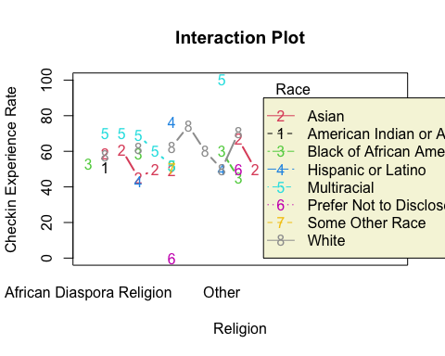

#### fly Claim Experience Rate

##### Gender vs Race

interaction.plot(  
 x.factor = travel_df_clean$race,  
 trace.factor = travel_df_clean$gender,  
 response = travel_df_clean$fly_exp,  
 type="b", col=c(1:4),  
 ylab = "Flight Experience Rate",  
 xlab = "Races",  
 trace.label = "Gender",  
 main="Interaction Plot",  
 leg.bty="o", leg.bg="beige", lwd=2,  
)

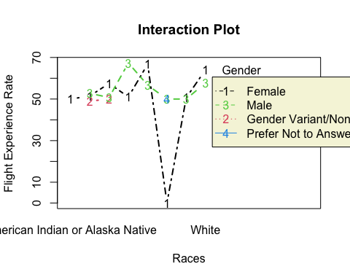

##### Gender vs Religion

interaction.plot(  
 x.factor = travel_df_clean$religion,  
 trace.factor = travel_df_clean$gender,  
 response = travel_df_clean$fly_exp,  
 type="b", col=c(1:4),  
 ylab = "Flight Experience Rate",  
 xlab = "Religion",  
 trace.label = "Gender",  
 main="Interaction Plot",  
 leg.bty="o", leg.bg="beige", lwd=2,  
)

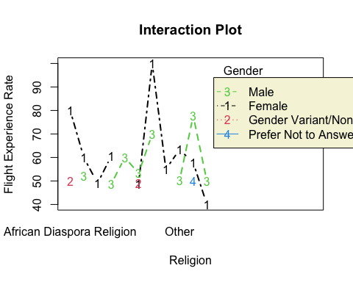

##### Race vs Religion

interaction.plot(  
 x.factor = travel_df_clean$religion,  
 trace.factor = travel_df_clean$race,  
 response = travel_df_clean$fly_exp,  
 type="b", col=c(1:8),  
 ylab = "Flight Experience Rate",  
 xlab = "Religion",  
 trace.label = "Race",  
 main="Interaction Plot",  
 leg.bty="o", leg.bg="beige", lwd=2  
)

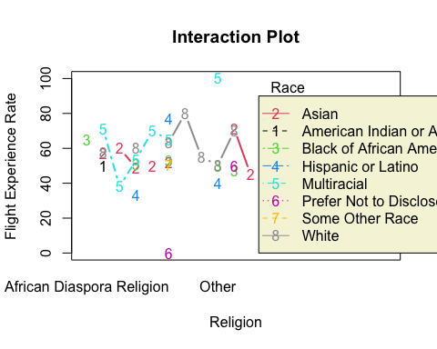

## 2. MANOVA

### ANOVA WITH INTERACTION : Gender and Religion as Factors

#### Dependent : checkin experience

aov_1 <- aov(checkin_exp ~ gender * religion, data = travel_df_clean)  
summary(aov_1)

## Df Sum Sq Mean Sq F value Pr(>F)   
## gender 3 706 235.3 0.844 0.4712   
## religion 10 4799 479.9 1.721 0.0777 .  
## gender:religion 7 3658 522.5 1.874 0.0752 .  
## Residuals 208 57983 278.8   
## ---  
## Signif. codes: 0 '***' 0.001 '**' 0.01 '*' 0.05 '.' 0.1 ' ' 1

#### Dependent : fly claim experience

aov_2 <- aov(fly_exp ~ gender * religion, data = travel_df_clean)  
summary(aov_2)

## Df Sum Sq Mean Sq F value Pr(>F)   
## gender 3 238 79.3 0.339 0.7972   
## religion 10 4296 429.6 1.837 0.0560 .  
## gender:religion 7 3626 518.1 2.215 0.0343 *  
## Residuals 208 48638 233.8   
## ---  
## Signif. codes: 0 '***' 0.001 '**' 0.01 '*' 0.05 '.' 0.1 ' ' 1

### ANOVA WITH INTERACTION : Gender and Race as Factors

#### Dependent : checkin experience

aov_1_ <- aov(checkin_exp ~ gender * race, data = travel_df_clean)  
summary(aov_1_)

## Df Sum Sq Mean Sq F value Pr(>F)   
## gender 3 706 235.3 0.890 0.447165   
## race 7 7724 1103.5 4.174 0.000251 ***  
## gender:race 7 2930 418.6 1.583 0.141709   
## Residuals 211 55784 264.4   
## ---  
## Signif. codes: 0 '***' 0.001 '**' 0.01 '*' 0.05 '.' 0.1 ' ' 1

#### Dependent : fly claim experience

aov_2_ <- aov(fly_exp ~ gender * race, data = travel_df_clean)  
summary(aov_2_)

## Df Sum Sq Mean Sq F value Pr(>F)   
## gender 3 238 79.3 0.337 0.79859   
## race 7 4694 670.6 2.852 0.00731 **  
## gender:race 7 2244 320.6 1.363 0.22235   
## Residuals 211 49622 235.2   
## ---  
## Signif. codes: 0 '***' 0.001 '**' 0.01 '*' 0.05 '.' 0.1 ' ' 1

### ANOVA WITH INTERACTION : Religion and Race as Factors

#### Dependent : checkin experience

aov_1_1 <- aov(checkin_exp ~ religion * race, data = travel_df_clean)  
summary(aov_1_1)

## Df Sum Sq Mean Sq F value Pr(>F)   
## religion 10 5242 524.2 1.994 0.03572 *   
## race 7 5177 739.6 2.814 0.00816 **  
## religion:race 14 4945 353.2 1.344 0.18461   
## Residuals 197 51781 262.8   
## ---  
## Signif. codes: 0 '***' 0.001 '**' 0.01 '*' 0.05 '.' 0.1 ' ' 1

#### Dependent : fly claim experience

aov_1_2 <- aov(fly_exp ~ religion * race, data = travel_df_clean)  
summary(aov_1_2)

## Df Sum Sq Mean Sq F value Pr(>F)   
## religion 10 4102 410.2 1.911 0.04556 *   
## race 7 4527 646.7 3.013 0.00498 **  
## religion:race 14 5888 420.5 1.959 0.02267 *   
## Residuals 197 42282 214.6   
## ---  
## Signif. codes: 0 '***' 0.001 '**' 0.01 '*' 0.05 '.' 0.1 ' ' 1

### TWO WAY MANOVA WITH INTERACTION : Gender and Race as Factors

manova1 <- manova(cbind(checkin_exp, fly_exp) ~ gender*race, data=travel_df_clean)  
summary(manova1)

## Df Pillai approx F num Df den Df Pr(>F)   
## gender 3 0.012843 0.45455 6 422 0.841726   
## race 7 0.143232 2.32523 14 422 0.004276 **  
## gender:race 7 0.067957 1.06023 14 422 0.392356   
## Residuals 211   
## ---  
## Signif. codes: 0 '***' 0.001 '**' 0.01 '*' 0.05 '.' 0.1 ' ' 1

summary.aov(manova1)

## Response checkin_exp :  
## Df Sum Sq Mean Sq F value Pr(>F)   
## gender 3 706 235.29 0.8900 0.447165   
## race 7 7724 1103.46 4.1737 0.000251 ***  
## gender:race 7 2930 418.63 1.5835 0.141709   
## Residuals 211 55784 264.38   
## ---  
## Signif. codes: 0 '***' 0.001 '**' 0.01 '*' 0.05 '.' 0.1 ' ' 1  
##   
## Response fly_exp :  
## Df Sum Sq Mean Sq F value Pr(>F)   
## gender 3 238 79.26 0.3370 0.798590   
## race 7 4694 670.63 2.8516 0.007308 **  
## gender:race 7 2244 320.62 1.3633 0.222354   
## Residuals 211 49622 235.17   
## ---  
## Signif. codes: 0 '***' 0.001 '**' 0.01 '*' 0.05 '.' 0.1 ' ' 1

### TWO WAY MANOVA WITH INTERACTION : Gender and Religion as Factors

manova2 <- manova(cbind(checkin_exp, fly_exp) ~ gender*religion, data=travel_df_clean)  
summary(manova2)

## Df Pillai approx F num Df den Df Pr(>F)  
## gender 3 0.012388 0.43212 6 416 0.8575  
## religion 10 0.126620 1.40585 20 416 0.1145  
## gender:religion 7 0.089753 1.39613 14 416 0.1511  
## Residuals 208

summary.aov(manova2)

## Response checkin_exp :  
## Df Sum Sq Mean Sq F value Pr(>F)   
## gender 3 706 235.29 0.8441 0.47116   
## religion 10 4799 479.87 1.7214 0.07767 .  
## gender:religion 7 3658 522.53 1.8745 0.07520 .  
## Residuals 208 57983 278.76   
## ---  
## Signif. codes: 0 '***' 0.001 '**' 0.01 '*' 0.05 '.' 0.1 ' ' 1  
##   
## Response fly_exp :  
## Df Sum Sq Mean Sq F value Pr(>F)   
## gender 3 238 79.26 0.3389 0.79719   
## religion 10 4296 429.60 1.8372 0.05599 .  
## gender:religion 7 3626 518.06 2.2155 0.03430 *  
## Residuals 208 48638 233.84   
## ---  
## Signif. codes: 0 '***' 0.001 '**' 0.01 '*' 0.05 '.' 0.1 ' ' 1

### TWO WAY MANOVA WITH INTERACTION : Gender and Religion as Factors

manova3 <- manova(cbind(checkin_exp, fly_exp) ~ race*religion, data=travel_df_clean)  
summary(manova3)

## Df Pillai approx F num Df den Df Pr(>F)   
## race 7 0.15825 2.4181 14 394 0.002913 **  
## religion 10 0.11246 1.1738 20 394 0.273406   
## race:religion 14 0.15838 1.2101 28 394 0.215616   
## Residuals 197   
## ---  
## Signif. codes: 0 '***' 0.001 '**' 0.01 '*' 0.05 '.' 0.1 ' ' 1

summary.aov(manova3)

## Response checkin_exp :  
## Df Sum Sq Mean Sq F value Pr(>F)   
## race 7 7866 1123.65 4.2749 0.0002017 ***  
## religion 10 2554 255.35 0.9715 0.4695651   
## race:religion 14 4945 353.22 1.3438 0.1846120   
## Residuals 197 51781 262.85   
## ---  
## Signif. codes: 0 '***' 0.001 '**' 0.01 '*' 0.05 '.' 0.1 ' ' 1  
##   
## Response fly_exp :  
## Df Sum Sq Mean Sq F value Pr(>F)   
## race 7 4488 641.10 2.9870 0.005313 **  
## religion 10 4141 414.12 1.9295 0.043194 *   
## race:religion 14 5888 420.54 1.9594 0.022670 *   
## Residuals 197 42282 214.63   
## ---  
## Signif. codes: 0 '***' 0.001 '**' 0.01 '*' 0.05 '.' 0.1 ' ' 1

### ASSUMPTION TEST : PILLAI

summary(manova3,  
 test = "Pillai")

## Df Pillai approx F num Df den Df Pr(>F)   
## race 7 0.15825 2.4181 14 394 0.002913 **  
## religion 10 0.11246 1.1738 20 394 0.273406   
## race:religion 14 0.15838 1.2101 28 394 0.215616   
## Residuals 197   
## ---  
## Signif. codes: 0 '***' 0.001 '**' 0.01 '*' 0.05 '.' 0.1 ' ' 1

### ASSUMPTION TEST : WILKS

summary(manova3,  
 test = "Wilks")

## Df Wilks approx F num Df den Df Pr(>F)   
## race 7 0.84308 2.4947 14 392 0.002088 **  
## religion 10 0.88951 1.1816 20 392 0.266324   
## race:religion 14 0.84493 1.2306 28 392 0.197405   
## Residuals 197   
## ---  
## Signif. codes: 0 '***' 0.001 '**' 0.01 '*' 0.05 '.' 0.1 ' ' 1

### ASSUMPTION TEST : HOTELLING-LAWLEY

summary(manova3,  
 test = "Hotelling-Lawley")

## Df Hotelling-Lawley approx F num Df den Df Pr(>F)   
## race 7 0.18456 2.5707 14 390 0.001496 **  
## religion 10 0.12199 1.1894 20 390 0.259486   
## race:religion 14 0.17960 1.2508 28 390 0.180543   
## Residuals 197   
## ---  
## Signif. codes: 0 '***' 0.001 '**' 0.01 '*' 0.05 '.' 0.1 ' ' 1

### ASSUMPTION TEST : ROY

summary(manova3,  
 test = "Roy")

## Df Roy approx F num Df den Df Pr(>F)   
## race 7 0.175617 4.9424 7 197 3.618e-05 ***  
## religion 10 0.099669 1.9635 10 197 0.03911 *   
## race:religion 14 0.154187 2.1696 14 197 0.01015 *   
## Residuals 197   
## ---  
## Signif. codes: 0 '***' 0.001 '**' 0.01 '*' 0.05 '.' 0.1 ' ' 1

Assume now, we’ll go with religion and race as factors based on MANOVA result.

## 3. CONTRAST

### Univariate Contrast

#### Race

M <- lm(cbind(checkin_exp, fly_exp) ~ race + religion, data = travel_df_clean)  
anova(M)

## Analysis of Variance Table  
##   
## Df Pillai approx F num Df den Df Pr(>F)   
## (Intercept) 1 0.94396 1768.60 2 210 < 2.2e-16 ***  
## race 7 0.14232 2.31 14 422 0.004579 **   
## religion 10 0.10105 1.12 20 422 0.322227   
## Residuals 211   
## ---  
## Signif. codes: 0 '***' 0.001 '**' 0.01 '*' 0.05 '.' 0.1 ' ' 1

mvpaircomp(M, factor1 = "race")

##   
## Multivariate Pairwise Comparisons  
##   
## Pillai approx F  
## American Indian or Alaska Native - Asian 0.000217 0.0228  
## American Indian or Alaska Native - Black of African American 0.000377 0.0396  
## American Indian or Alaska Native - Hispanic or Latino 0.003111 0.3277  
## American Indian or Alaska Native - Multiracial 0.005985 0.6322  
## American Indian or Alaska Native - Prefer Not to Disclose 0.005584 0.5896  
## American Indian or Alaska Native - Some Other Race 0.000023 0.0024  
## American Indian or Alaska Native - White 0.002961 0.3118  
## Asian - Black of African American 0.004251 0.4482  
## Asian - Hispanic or Latino 0.017110 1.8278  
## Asian - Multiracial 0.049315 5.4467  
## Asian - Prefer Not to Disclose 0.024622 2.6506  
## Asian - Some Other Race 0.000663 0.0696  
## Asian - White 0.068436 7.7137  
## Black of African American - Hispanic or Latino 0.005302 0.5597  
## Black of African American - Multiracial 0.016090 1.7170  
## Black of African American - Prefer Not to Disclose 0.025063 2.6993  
## Black of African American - Some Other Race 0.001841 0.1937  
## Black of African American - White 0.009006 0.9542  
## Hispanic or Latino - Multiracial 0.001634 0.1718  
## Hispanic or Latino - Prefer Not to Disclose 0.039136 4.2767  
## Hispanic or Latino - Some Other Race 0.010743 1.1402  
## Hispanic or Latino - White 0.001062 0.1116  
## Multiracial - Prefer Not to Disclose 0.057569 6.4139  
## Multiracial - Some Other Race 0.024045 2.5870  
## Multiracial - White 0.008894 0.9422  
## Prefer Not to Disclose - Some Other Race 0.014456 1.5402  
## Prefer Not to Disclose - White 0.052484 5.8161  
## Some Other Race - White 0.015793 1.6849  
## num DF den DF  
## American Indian or Alaska Native - Asian 2 210  
## American Indian or Alaska Native - Black of African American 2 210  
## American Indian or Alaska Native - Hispanic or Latino 2 210  
## American Indian or Alaska Native - Multiracial 2 210  
## American Indian or Alaska Native - Prefer Not to Disclose 2 210  
## American Indian or Alaska Native - Some Other Race 2 210  
## American Indian or Alaska Native - White 2 210  
## Asian - Black of African American 2 210  
## Asian - Hispanic or Latino 2 210  
## Asian - Multiracial 2 210  
## Asian - Prefer Not to Disclose 2 210  
## Asian - Some Other Race 2 210  
## Asian - White 2 210  
## Black of African American - Hispanic or Latino 2 210  
## Black of African American - Multiracial 2 210  
## Black of African American - Prefer Not to Disclose 2 210  
## Black of African American - Some Other Race 2 210  
## Black of African American - White 2 210  
## Hispanic or Latino - Multiracial 2 210  
## Hispanic or Latino - Prefer Not to Disclose 2 210  
## Hispanic or Latino - Some Other Race 2 210  
## Hispanic or Latino - White 2 210  
## Multiracial - Prefer Not to Disclose 2 210  
## Multiracial - Some Other Race 2 210  
## Multiracial - White 2 210  
## Prefer Not to Disclose - Some Other Race 2 210  
## Prefer Not to Disclose - White 2 210  
## Some Other Race - White 2 210  
## Pr(>F)   
## American Indian or Alaska Native - Asian 0.9774660   
## American Indian or Alaska Native - Black of African American 0.9611607   
## American Indian or Alaska Native - Hispanic or Latino 0.7209785   
## American Indian or Alaska Native - Multiracial 0.5324069   
## American Indian or Alaska Native - Prefer Not to Disclose 0.5554651   
## American Indian or Alaska Native - Some Other Race 0.9975944   
## American Indian or Alaska Native - White 0.7324412   
## Asian - Black of African American 0.6393624   
## Asian - Hispanic or Latino 0.1633143   
## Asian - Multiracial 0.0049415 **   
## Asian - Prefer Not to Disclose 0.0729733 .   
## Asian - Some Other Race 0.9327803   
## Asian - White 0.0005852 ***  
## Black of African American - Hispanic or Latino 0.5722235   
## Black of African American - Multiracial 0.1821075   
## Black of African American - Prefer Not to Disclose 0.0695854 .   
## Black of African American - Some Other Race 0.8240694   
## Black of African American - White 0.3867768   
## Hispanic or Latino - Multiracial 0.8422401   
## Hispanic or Latino - Prefer Not to Disclose 0.0151182 *   
## Hispanic or Latino - Some Other Race 0.3217224   
## Hispanic or Latino - White 0.8944385   
## Multiracial - Prefer Not to Disclose 0.0019780 **   
## Multiracial - Some Other Race 0.0776436 .   
## Multiracial - White 0.3913989   
## Prefer Not to Disclose - Some Other Race 0.2167540   
## Prefer Not to Disclose - White 0.0034799 **   
## Some Other Race - White 0.1879651   
## ---  
## Signif. codes: 0 '***' 0.001 '**' 0.01 '*' 0.05 '.' 0.1 ' ' 1  
## With none p-value adjustment for multiple comparisons

#### Religion

M <- lm(cbind(checkin_exp, fly_exp) ~ race + religion, data = travel_df_clean)  
anova(M)

## Analysis of Variance Table  
##   
## Df Pillai approx F num Df den Df Pr(>F)   
## (Intercept) 1 0.94396 1768.60 2 210 < 2.2e-16 ***  
## race 7 0.14232 2.31 14 422 0.004579 **   
## religion 10 0.10105 1.12 20 422 0.322227   
## Residuals 211   
## ---  
## Signif. codes: 0 '***' 0.001 '**' 0.01 '*' 0.05 '.' 0.1 ' ' 1

mvpaircomp(M, factor1 = "religion")

##   
## Multivariate Pairwise Comparisons  
##   
## Pillai approx F  
## African Diaspora Religion - Atheism/Agnosticism 0.005803 0.6128  
## African Diaspora Religion - Buddhism 0.015783 1.6838  
## African Diaspora Religion - Christianity 0.008506 0.9008  
## African Diaspora Religion - Hinduism 0.001051 0.1104  
## African Diaspora Religion - Islam 0.007313 0.7735  
## African Diaspora Religion - Judaism 0.010376 1.1009  
## African Diaspora Religion - Judaism,Atheism/Agnosticism 0.003831 0.4038  
## African Diaspora Religion - Other 0.007954 0.8419  
## African Diaspora Religion - Prefer Not to Disclose 0.003366 0.3546  
## African Diaspora Religion - Sikhism 0.009714 1.0300  
## Atheism/Agnosticism - Buddhism 0.008577 0.9084  
## Atheism/Agnosticism - Christianity 0.001644 0.1729  
## Atheism/Agnosticism - Hinduism 0.001165 0.1225  
## Atheism/Agnosticism - Islam 0.019443 2.0820  
## Atheism/Agnosticism - Judaism 0.026511 2.8595  
## Atheism/Agnosticism - Judaism,Atheism/Agnosticism 0.000336 0.0353  
## Atheism/Agnosticism - Other 0.001069 0.1124  
## Atheism/Agnosticism - Prefer Not to Disclose 0.004257 0.4489  
## Atheism/Agnosticism - Sikhism 0.006005 0.6344  
## Buddhism - Christianity 0.006638 0.7017  
## Buddhism - Hinduism 0.008906 0.9436  
## Buddhism - Islam 0.014118 1.5036  
## Buddhism - Judaism 0.025188 2.7131  
## Buddhism - Judaism,Atheism/Agnosticism 0.001716 0.1804  
## Buddhism - Other 0.004657 0.4912  
## Buddhism - Prefer Not to Disclose 0.012653 1.3456  
## Buddhism - Sikhism 0.004504 0.4751  
## Christianity - Hinduism 0.002338 0.2461  
## Christianity - Islam 0.025530 2.7509  
## Christianity - Judaism 0.034223 3.7207  
## Christianity - Judaism,Atheism/Agnosticism 0.000102 0.0107  
## Christianity - Other 0.000428 0.0450  
## Christianity - Prefer Not to Disclose 0.010280 1.0906  
## Christianity - Sikhism 0.004169 0.4395  
## Hinduism - Islam 0.002438 0.2566  
## Hinduism - Judaism 0.011810 1.2549  
## Hinduism - Judaism,Atheism/Agnosticism 0.001291 0.1357  
## Hinduism - Other 0.002496 0.2628  
## Hinduism - Prefer Not to Disclose 0.001211 0.1273  
## Hinduism - Sikhism 0.004894 0.5164  
## Islam - Judaism 0.049921 5.5172  
## Islam - Judaism,Atheism/Agnosticism 0.001818 0.1912  
## Islam - Other 0.011661 1.2388  
## Islam - Prefer Not to Disclose 0.026984 2.9119  
## Islam - Sikhism 0.002902 0.3056  
## Judaism - Judaism,Atheism/Agnosticism 0.009644 1.0225  
## Judaism - Other 0.024838 2.6744  
## Judaism - Prefer Not to Disclose 0.013250 1.4100  
## Judaism - Sikhism 0.030318 3.2829  
## Judaism,Atheism/Agnosticism - Other 0.000018 0.0019  
## Judaism,Atheism/Agnosticism - Prefer Not to Disclose 0.001590 0.1672  
## Judaism,Atheism/Agnosticism - Sikhism 0.001703 0.1791  
## Other - Prefer Not to Disclose 0.005534 0.5843  
## Other - Sikhism 0.004390 0.4629  
## Prefer Not to Disclose - Sikhism 0.011622 1.2346  
## num DF den DF Pr(>F)  
## African Diaspora Religion - Atheism/Agnosticism 2 210 0.542774  
## African Diaspora Religion - Buddhism 2 210 0.188168  
## African Diaspora Religion - Christianity 2 210 0.407824  
## African Diaspora Religion - Hinduism 2 210 0.895498  
## African Diaspora Religion - Islam 2 210 0.462711  
## African Diaspora Religion - Judaism 2 210 0.334476  
## African Diaspora Religion - Judaism,Atheism/Agnosticism 2 210 0.668325  
## African Diaspora Religion - Other 2 210 0.432343  
## African Diaspora Religion - Prefer Not to Disclose 2 210 0.701878  
## African Diaspora Religion - Sikhism 2 210 0.358819  
## Atheism/Agnosticism - Buddhism 2 210 0.404743  
## Atheism/Agnosticism - Christianity 2 210 0.841329  
## Atheism/Agnosticism - Hinduism 2 210 0.884794  
## Atheism/Agnosticism - Islam 2 210 0.127250  
## Atheism/Agnosticism - Judaism 2 210 0.059532  
## Atheism/Agnosticism - Judaism,Atheism/Agnosticism 2 210 0.965319  
## Atheism/Agnosticism - Other 2 210 0.893753  
## Atheism/Agnosticism - Prefer Not to Disclose 2 210 0.638970  
## Atheism/Agnosticism - Sikhism 2 210 0.531289  
## Buddhism - Christianity 2 210 0.496913  
## Buddhism - Hinduism 2 210 0.390885  
## Buddhism - Islam 2 210 0.224716  
## Buddhism - Judaism 2 210 0.068657  
## Buddhism - Judaism,Atheism/Agnosticism 2 210 0.835031  
## Buddhism - Other 2 210 0.612571  
## Buddhism - Prefer Not to Disclose 2 210 0.262614  
## Buddhism - Sikhism 2 210 0.622502  
## Christianity - Hinduism 2 210 0.782080  
## Christianity - Islam 2 210 0.066173  
## Christianity - Judaism 2 210 0.025828  
## Christianity - Judaism,Atheism/Agnosticism 2 210 0.989352  
## Christianity - Other 2 210 0.956003  
## Christianity - Prefer Not to Disclose 2 210 0.337911  
## Christianity - Sikhism 2 210 0.644925  
## Hinduism - Islam 2 210 0.773924  
## Hinduism - Judaism 2 210 0.287233  
## Hinduism - Judaism,Atheism/Agnosticism 2 210 0.873168  
## Hinduism - Other 2 210 0.769160  
## Hinduism - Prefer Not to Disclose 2 210 0.880572  
## Hinduism - Sikhism 2 210 0.597429  
## Islam - Judaism 2 210 0.004621  
## Islam - Judaism,Atheism/Agnosticism 2 210 0.826098  
## Islam - Other 2 210 0.291835  
## Islam - Prefer Not to Disclose 2 210 0.056571  
## Islam - Sikhism 2 210 0.737021  
## Judaism - Judaism,Atheism/Agnosticism 2 210 0.361479  
## Judaism - Other 2 210 0.071299  
## Judaism - Prefer Not to Disclose 2 210 0.246453  
## Judaism - Sikhism 2 210 0.039454  
## Judaism,Atheism/Agnosticism - Other 2 210 0.998119  
## Judaism,Atheism/Agnosticism - Prefer Not to Disclose 2 210 0.846120  
## Judaism,Atheism/Agnosticism - Sikhism 2 210 0.836153  
## Other - Prefer Not to Disclose 2 210 0.558407  
## Other - Sikhism 2 210 0.630068  
## Prefer Not to Disclose - Sikhism 2 210 0.293042  
##   
## African Diaspora Religion - Atheism/Agnosticism   
## African Diaspora Religion - Buddhism   
## African Diaspora Religion - Christianity   
## African Diaspora Religion - Hinduism   
## African Diaspora Religion - Islam   
## African Diaspora Religion - Judaism   
## African Diaspora Religion - Judaism,Atheism/Agnosticism   
## African Diaspora Religion - Other   
## African Diaspora Religion - Prefer Not to Disclose   
## African Diaspora Religion - Sikhism   
## Atheism/Agnosticism - Buddhism   
## Atheism/Agnosticism - Christianity   
## Atheism/Agnosticism - Hinduism   
## Atheism/Agnosticism - Islam   
## Atheism/Agnosticism - Judaism .   
## Atheism/Agnosticism - Judaism,Atheism/Agnosticism   
## Atheism/Agnosticism - Other   
## Atheism/Agnosticism - Prefer Not to Disclose   
## Atheism/Agnosticism - Sikhism   
## Buddhism - Christianity   
## Buddhism - Hinduism   
## Buddhism - Islam   
## Buddhism - Judaism .   
## Buddhism - Judaism,Atheism/Agnosticism   
## Buddhism - Other   
## Buddhism - Prefer Not to Disclose   
## Buddhism - Sikhism   
## Christianity - Hinduism   
## Christianity - Islam .   
## Christianity - Judaism *   
## Christianity - Judaism,Atheism/Agnosticism   
## Christianity - Other   
## Christianity - Prefer Not to Disclose   
## Christianity - Sikhism   
## Hinduism - Islam   
## Hinduism - Judaism   
## Hinduism - Judaism,Atheism/Agnosticism   
## Hinduism - Other   
## Hinduism - Prefer Not to Disclose   
## Hinduism - Sikhism   
## Islam - Judaism **  
## Islam - Judaism,Atheism/Agnosticism   
## Islam - Other   
## Islam - Prefer Not to Disclose .   
## Islam - Sikhism   
## Judaism - Judaism,Atheism/Agnosticism   
## Judaism - Other .   
## Judaism - Prefer Not to Disclose   
## Judaism - Sikhism *   
## Judaism,Atheism/Agnosticism - Other   
## Judaism,Atheism/Agnosticism - Prefer Not to Disclose   
## Judaism,Atheism/Agnosticism - Sikhism   
## Other - Prefer Not to Disclose   
## Other - Sikhism   
## Prefer Not to Disclose - Sikhism   
## ---  
## Signif. codes: 0 '***' 0.001 '**' 0.01 '*' 0.05 '.' 0.1 ' ' 1  
## With none p-value adjustment for multiple comparisons

### Multivariate Contrast

MOats.lm <- lm(cbind(checkin_exp, fly_exp) ~ race + religion, data = travel_df_clean)  
MOats.emm <- emmeans(MOats.lm, ~ race| rep.meas)  
mvcontrast(MOats.emm, "consec", show.ests = TRUE)

## $estimates  
## contrast = Asian - American Indian or Alaska Native:  
## rep.meas estimate SE df t.ratio p.value  
## checkin_exp 3.34 17.02 211 0.196 0.8445  
## fly_exp 4.14 15.68 211 0.264 0.7920  
##   
## contrast = Black of African American - Asian:  
## rep.meas estimate SE df t.ratio p.value  
## checkin_exp 3.37 7.13 211 0.473 0.6369  
## fly_exp -2.54 6.57 211 -0.387 0.6991  
##   
## contrast = Hispanic or Latino - Black of African American:  
## rep.meas estimate SE df t.ratio p.value  
## checkin_exp 10.89 9.76 211 1.115 0.2660  
## fly_exp 12.05 9.00 211 1.340 0.1817  
##   
## contrast = Multiracial - Hispanic or Latino:  
## rep.meas estimate SE df t.ratio p.value  
## checkin_exp 4.46 9.69 211 0.460 0.6463  
## fly_exp 3.23 8.93 211 0.362 0.7177  
##   
## contrast = Prefer Not to Disclose - Multiracial:  
## rep.meas estimate SE df t.ratio p.value  
## checkin_exp -45.43 12.15 211 -3.738 0.0002  
## fly_exp -42.71 11.20 211 -3.814 0.0002  
##   
## contrast = Some Other Race - Prefer Not to Disclose:  
## rep.meas estimate SE df t.ratio p.value  
## checkin_exp 27.26 12.32 211 2.213 0.0279  
## fly_exp 28.16 11.35 211 2.481 0.0139  
##   
## contrast = White - Some Other Race:  
## rep.meas estimate SE df t.ratio p.value  
## checkin_exp 7.29 7.94 211 0.919 0.3593  
## fly_exp 9.09 7.32 211 1.243 0.2154  
##   
## Results are averaged over the levels of: religion   
##   
## $tests  
## contrast T.square df1 df2 F.ratio  
## Asian - American Indian or Alaska Native 0.075 2 210 0.037  
## Black of African American - Asian 0.750 2 210 0.373  
## Hispanic or Latino - Black of African American 2.053 2 210 1.022  
## Multiracial - Hispanic or Latino 0.234 2 210 0.116  
## Prefer Not to Disclose - Multiracial 18.947 2 210 9.429  
## Some Other Race - Prefer Not to Disclose 7.392 2 210 3.679  
## White - Some Other Race 1.658 2 210 0.825  
## p.value  
## 1.0000  
## 0.9997  
## 0.9569  
## 1.0000  
## 0.0008  
## 0.1738  
## 0.9827  
##   
## P value adjustment: sidak

MOats.lm2 <- lm(cbind(checkin_exp, fly_exp) ~ race + religion, data = travel_df_clean)  
MOats.emm2 <- emmeans(MOats.lm, ~ religion| rep.meas)  
mvcontrast(MOats.emm2, "consec", show.ests = TRUE)

## $estimates  
## contrast = (Atheism/Agnosticism) - African Diaspora Religion:  
## rep.meas estimate SE df t.ratio p.value  
## checkin_exp 4.71 14.02 211 0.336 0.7373  
## fly_exp -13.40 12.92 211 -1.037 0.3010  
##   
## contrast = Buddhism - (Atheism/Agnosticism):  
## rep.meas estimate SE df t.ratio p.value  
## checkin_exp 1.80 12.66 211 0.142 0.8870  
## fly_exp -11.52 11.67 211 -0.987 0.3248  
##   
## contrast = Christianity - Buddhism:  
## rep.meas estimate SE df t.ratio p.value  
## checkin_exp -5.29 12.41 211 -0.426 0.6705  
## fly_exp 7.11 11.43 211 0.622 0.5347  
##   
## contrast = Hinduism - Christianity:  
## rep.meas estimate SE df t.ratio p.value  
## checkin_exp -5.21 12.41 211 -0.420 0.6747  
## fly_exp 3.89 11.43 211 0.340 0.7340  
##   
## contrast = Islam - Hinduism:  
## rep.meas estimate SE df t.ratio p.value  
## checkin_exp 3.99 12.12 211 0.329 0.7427  
## fly_exp -1.49 11.17 211 -0.133 0.8943  
##   
## contrast = Judaism - Islam:  
## rep.meas estimate SE df t.ratio p.value  
## checkin_exp 16.87 10.38 211 1.625 0.1057  
## fly_exp 20.58 9.57 211 2.150 0.0327  
##   
## contrast = (Judaism,Atheism/Agnosticism) - Judaism:  
## rep.meas estimate SE df t.ratio p.value  
## checkin_exp -14.33 18.93 211 -0.757 0.4499  
## fly_exp -25.00 17.45 211 -1.433 0.1534  
##   
## contrast = Other - (Judaism,Atheism/Agnosticism):  
## rep.meas estimate SE df t.ratio p.value  
## checkin_exp -1.20 17.77 211 -0.067 0.9463  
## fly_exp 2.57 16.37 211 0.157 0.8756  
##   
## contrast = Prefer Not to Disclose - Other:  
## rep.meas estimate SE df t.ratio p.value  
## checkin_exp 14.30 8.90 211 1.606 0.1098  
## fly_exp 18.60 8.20 211 2.267 0.0244  
##   
## contrast = Sikhism - Prefer Not to Disclose:  
## rep.meas estimate SE df t.ratio p.value  
## checkin_exp -15.27 13.13 211 -1.163 0.2460  
## fly_exp -23.88 12.09 211 -1.974 0.0497  
##   
## Results are averaged over the levels of: race   
##   
## $tests  
## contrast T.square df1 df2 F.ratio  
## (Atheism/Agnosticism) - African Diaspora Religion 2.069 2 210 1.029  
## Buddhism - (Atheism/Agnosticism) 1.526 2 210 0.760  
## Christianity - Buddhism 1.123 2 210 0.559  
## Hinduism - Christianity 0.587 2 210 0.292  
## Islam - Hinduism 0.228 2 210 0.114  
## Judaism - Islam 5.012 2 210 2.494  
## (Judaism,Atheism/Agnosticism) - Judaism 2.055 2 210 1.022  
## Other - (Judaism,Atheism/Agnosticism) 0.053 2 210 0.027  
## Prefer Not to Disclose - Other 5.422 2 210 2.698  
## Sikhism - Prefer Not to Disclose 3.934 2 210 1.958  
## p.value  
## 0.9883  
## 0.9982  
## 0.9998  
## 1.0000  
## 1.0000  
## 0.5888  
## 0.9887  
## 1.0000  
## 0.5143  
## 0.7881  
##   
## P value adjustment: sidak

## 4. MANCOVA

#### Plot : travel_frequency vs checkin_exp

plot(travel_df_clean$travel_frequency, travel_df_clean$checkin_exp, main="Scatterplot of Travel Frequency vs Check In Experience Rate",  
 xlab="travel_frequency ", ylab="Check_in_exp ", pch=19)

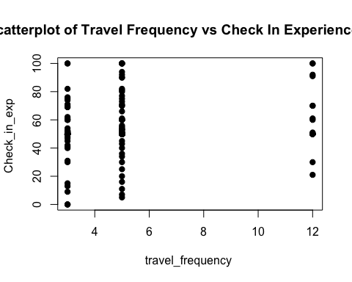 #### Plot : travel_frequency vs flight_exp

plot(travel_df_clean$travel_frequency, travel_df_clean$fly_exp, main="Scatterplot of Travel Frequency vs Flight Experience Rate",  
 xlab="travel_frequency ", ylab="flight_exp ", pch=19)

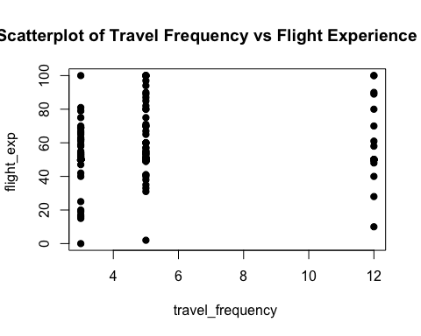 Now we add travel_frequency as covariates.

results <- mancova(data = travel_df_clean,  
 deps = vars(checkin_exp, fly_exp),  
 factors = vars(race, religion),  
 covs = travel_frequency,  
 multivar = list("pillai", "wilks", "hotel", "roy"), boxM = T,  
 shapiro = T, qqPlot = T)

### MULTIVARIATE MANCOVA

results$multivar

##   
## Multivariate Tests   
## ───────────────────────────────────────────────────────────────────────────────────────────────   
## value F df1 df2 p   
## ───────────────────────────────────────────────────────────────────────────────────────────────   
## race Pillai's Trace 0.15986903 2.432616 14 392 0.0027387   
## Wilks' Lambda 0.8414697 2.510936 14 390 0.0019474   
## Hotelling's Trace 0.18680589 2.588596 14 388 0.0013842   
## Roy's Largest Root 0.17786080 4.980102 7 196 0.0000330   
##   
## religion Pillai's Trace 0.11326700 1.176655 20 392 0.2708282   
## Wilks' Lambda 0.8887351 1.184662 20 390 0.2636560   
## Hotelling's Trace 0.12294182 1.192536 20 388 0.2567352   
## Roy's Largest Root 0.10053336 1.970454 10 196 0.0383495   
##   
## race:religion Pillai's Trace 0.15137166 1.146365 28 392 0.2801717   
## Wilks' Lambda 0.8516551 1.164398 28 390 0.2608121   
## Hotelling's Trace 0.17063032 1.182224 28 388 0.2425808   
## Roy's Largest Root 0.14634566 2.048839 14 196 0.0161958   
##   
## travel_frequency Pillai's Trace 0.02296571 2.291789 2 195 0.1038021   
## Wilks' Lambda 0.9770343 2.291789 2 195 0.1038021   
## Hotelling's Trace 0.02350553 2.291789 2 195 0.1038021   
## Roy's Largest Root 0.02350553 2.291789 2 195 0.1038021   
## ───────────────────────────────────────────────────────────────────────────────────────────────

#### UNIVARIATE MANCOVA

results$univar

##   
## Univariate Tests   
## ────────────────────────────────────────────────────────────────────────────────────────────────────────────   
## Dependent Variable Sum of Squares df Mean Square F p   
## ────────────────────────────────────────────────────────────────────────────────────────────────────────────   
## race checkin_exp 7865.5333 7 1123.6476 4.3018270 0.0001889   
## fly_exp 4487.6795 7 641.0971 2.9919084 0.0052568   
## religion checkin_exp 2553.5320 10 255.3532 0.9776066 0.4642214   
## fly_exp 4141.2498 10 414.1250 1.9326621 0.0428314   
## race:religion checkin_exp 4483.6256 14 320.2590 1.2260950 0.2587589   
## fly_exp 5617.5024 14 401.2502 1.8725772 0.0313073   
## travel_frequency checkin_exp 1046.5956 1 1046.5956 4.0068373 0.0466951   
## fly_exp 553.5446 1 553.5446 2.5833137 0.1096051   
## Residuals checkin_exp 51195.6742 196 261.2024   
## fly_exp 41998.2857 196 214.2770   
## ────────────────────────────────────────────────────────────────────────────────────────────────────────────

## 5. MODEL ASSUMPTION

### A. BOX M

results$assump$boxM

##   
## Box's Homogeneity of Covariance Matrices Test   
## ─────────────────────────────────────────────   
## χ² df p   
## ─────────────────────────────────────────────   
## ᵃ 93 ᵃ   
## ─────────────────────────────────────────────   
## ᵃ Too few observations to calculate  
## statistic. Each (sub)group must have at  
## least as many observations as there are  
## dependent variables.

### B. SHAPIRO WILK TEST

results$assump$shapiro

##   
## Shapiro-Wilk Multivariate Normality Test   
## ────────────────────────────────────────   
## W p   
## ────────────────────────────────────────   
## 0.7267987 < .0000001   
## ────────────────────────────────────────

### C. QQ-PLOT

results$assump$qqPlot

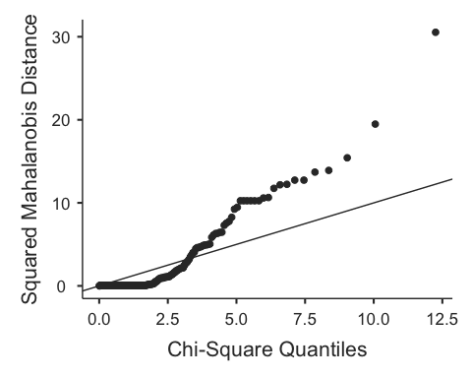

## 6. MRPP : Multiresponse permutation procedures

y <- as.matrix(travel_df_clean[,2:3])  
y_mat <- sqrt(y) # square root transformation

y_dist <- vegdist(y_mat)

set.seed(123)  
mrpp <- adonis2(y_dist~ travel_df_clean$race * travel_df_clean$religion, permutations = 1000)  
mrpp

## Permutation test for adonis under reduced model  
## Terms added sequentially (first to last)  
## Permutation: free  
## Number of permutations: 1000  
##   
## adonis2(formula = y_dist ~ travel_df_clean$race * travel_df_clean$religion, permutations = 1000)  
## Df SumOfSqs R2 F  
## travel_df_clean$race 7 0.40884 0.15914 8.2778  
## travel_df_clean$religion 10 0.09878 0.03845 1.4000  
## travel_df_clean$race:travel_df_clean$religion 14 0.67142 0.26135 6.7972  
## Residual 197 1.38997 0.54105   
## Total 228 2.56901 1.00000   
## Pr(>F)   
## travel_df_clean$race 0.007992 **  
## travel_df_clean$religion 0.194805   
## travel_df_clean$race:travel_df_clean$religion 0.031968 *   
## Residual   
## Total   
## ---  
## Signif. codes: 0 '***' 0.001 '**' 0.01 '*' 0.05 '.' 0.1 ' ' 1